Question 1:
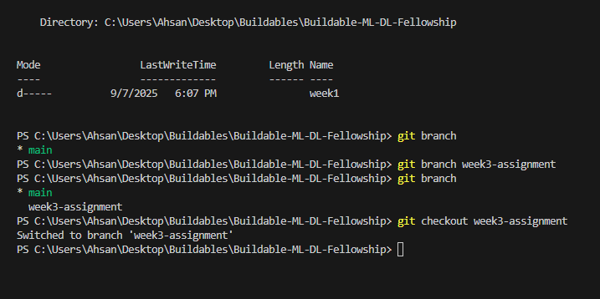

Question 2:
Code:
import random
import numpy as np
import pandas as pd
import os

class DataGenerator:
def __init__(self, n_rows=500, save_path="data/raw/generated_data.csv", seed=None):
self.n_rows = n_rows
self.save_path = save_path
if seed is not None:
random.seed(seed)
np.random.seed(seed)

def generate_numeric_features(self):
"""Generate numerical features such as age, income, etc."""
age = np.random.randint(18, 70, self.n_rows)
income = np.random.randint(20000, 150000, self.n_rows)
score = np.random.randint(0, 100, self.n_rows)
years_of_experience = np.random.randint(0, 40, self.n_rows)
purchases_last_year = np.random.randint(0, 50, self.n_rows)
return age, income, score, years_of_experience, purchases_last_year

def generate_categorical_features(self):
"""Generate categorical features such as gender, product type, etc."""
gender = np.random.choice(["Male", "Female", "Other"], self.n_rows, p=[0.48, 0.48, 0.04])
product_type = np.random.choice(["Electronics", "Clothing", "Food", "Books"], self.n_rows)
return gender, product_type

def generate_target(self, income, score):
"""Generate a binary target (classification)."""
# Higher income and score → more likely to purchase
probs = (income / income.max()) * 0.5 + (score / 100) * 0.5
purchase = np.random.binomial(1, probs)
return purchase

def generate_dataset(self):
"""Generate the entire dataset and return as a DataFrame."""
age, income, score, exp, purchases = self.generate_numeric_features()
gender, product = self.generate_categorical_features()
purchase = self.generate_target(income, score)

data = pd.DataFrame({
"Age": age,
"Income": income,
"Score": score,
"Experience": exp,
"Purchases_Last_Year": purchases,
"Gender": gender,
"Product_Type": product,
"Purchased": purchase
})
return data

def save_dataset(self, data):
"""Save dataset to CSV."""
os.makedirs(os.path.dirname(self.save_path), exist_ok=True)
data.to_csv(self.save_path, index=False)
print(f" Dataset saved to {self.save_path}")

def run(self):
"""Generate and save dataset in one go."""
data = self.generate_dataset()
self.save_dataset(data)
return data

# Example usage
if __name__ == "__main__":
generator = DataGenerator(n_rows=500, save_path="data/raw/generated_data.csv", seed=42)
df = generator.run()
print(df.head())
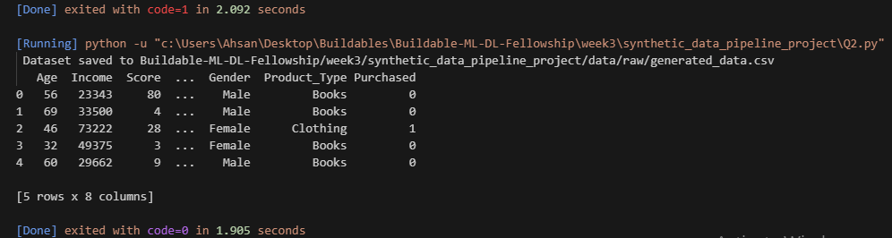

Report:
Object-Oriented Programming (OOP) and Reusability in Data Generator
Introduction
In this task, a Python class DataGenerator was developed to create synthetic datasets that mimic real-world scenarios. The generator produces numerical features (e.g., age, income), categorical features (e.g., gender, product type), and a binary target column (e.g., purchase decision). The dataset is saved to a CSV file for later use.
This report explains how Object-Oriented Programming (OOP) principles and reusability contribute to making the generator flexible, scalable, and easy to maintain.

Role of OOP in the Data Generator
1. Encapsulation
All dataset creation logic is bundled inside the DataGenerator class. This ensures that related methods—such as generating numerical features, categorical features, target variables, and saving data—are organized in one place. As a result, the code becomes easier to understand, debug, and maintain.
2. Abstraction
Each function within the class performs a clear and specific role (e.g., generate_numeric_features, generate_categorical_features, generate_target). This abstraction hides complex implementation details from the user. The user only needs to call the run() method without worrying about the underlying data generation process.
3. Reusability
Because the class is modular, the same codebase can be reused for multiple applications. For example:
- In a customer dataset, features might include income and purchases.
- In a patient dataset, features could include age, blood pressure, and disease status.
Only minor modifications are required, while the overall structure remains reusable.
4. Scalability and Flexibility
The constructor (__init__) allows the user to adjust key parameters such as number of rows, file save path, and random seed. This flexibility makes it easy to scale up to larger datasets, change output locations, or ensure reproducibility without rewriting the code.
5. Maintainability
If an error or improvement is needed—for example, refining the probability distribution for the target variable—the fix only needs to be made in one method. This centralized approach reduces duplication and makes the code more maintainable over time.

Reusability Benefits in Practice
- Expanding Features
New features such as "Education Level," "Marital Status," or "Transaction Type" can be added by creating additional methods. Existing code does not need to be rewritten.
- Different Scenarios
By changing just the generation logic, the same class can produce synthetic data for customers, students, patients, or financial transactions.
- Task Adaptability
The class can be extended to support regression problems (e.g., predicting income or health score) in addition to classification tasks. This makes it versatile across different machine learning workflows.

Conclusion
The DataGenerator class demonstrates the strengths of Object-Oriented Programming in developing reusable and maintainable code. Encapsulation, abstraction, and modular design make it easy to expand the generator to new domains, add more features, or adjust its behavior. Reusability ensures that the same code structure can serve multiple projects with minimal modifications, making it an efficient and practical solution for synthetic data generation.


Question 3:
Code:
import os
import numpy as np
import pandas as pd
import random
import datetime

class InvalidFilePathError(Exception):
"""Raised when the file path is invalid."""
pass

class DataGenerationError(Exception):
"""Raised when dataset generation fails due to wrong parameters."""
pass

class DataGenerator:
def __init__(self, n_rows=500, save_path="Buildable-ML-DL-Fellowship/week3/synthetic_data_pipeline_project/data/raw/generated_data.csv", seed=None):
self.n_rows = n_rows
self.save_path = save_path
if seed is not None:
random.seed(seed)
np.random.seed(seed)

def log_error(self, message):
"""Log errors to logs/errors.txt"""
os.makedirs("logs", exist_ok=True)
with open("logs/errors.txt", "a") as f:
timestamp = datetime.datetime.now().strftime("%Y-%m-%d %H:%M:%S")
f.write(f"[{timestamp}] {message}\n")

def generate_numeric_features(self):
if self.n_rows <= 0:
raise DataGenerationError("Number of rows must be greater than zero.")
age = np.random.randint(18, 70, self.n_rows)
income = np.random.randint(20000, 150000, self.n_rows)
score = np.random.randint(0, 100, self.n_rows)
years_of_experience = np.random.randint(0, 40, self.n_rows)
purchases_last_year = np.random.randint(0, 50, self.n_rows)
return age, income, score, years_of_experience, purchases_last_year

def generate_categorical_features(self):
gender = np.random.choice(["Male", "Female", "Other"], self.n_rows, p=[0.48, 0.48, 0.04])
product_type = np.random.choice(["Electronics", "Clothing", "Food", "Books"], self.n_rows)
return gender, product_type

def generate_target(self, income, score):
probs = (income / income.max()) * 0.5 + (score / 100) * 0.5
purchase = np.random.binomial(1, probs)
return purchase

def generate_dataset(self):
try:
age, income, score, exp, purchases = self.generate_numeric_features()
gender, product = self.generate_categorical_features()
purchase = self.generate_target(income, score)

data = pd.DataFrame({
"Age": age,
"Income": income,
"Score": score,
"Experience": exp,
"Purchases_Last_Year": purchases,
"Gender": gender,
"Product_Type": product,
"Purchased": purchase
})
return data
except DataGenerationError as e:
self.log_error(str(e))
raise

def save_dataset(self, data):
try:
# Validate path
folder = os.path.dirname(self.save_path)
if folder and not os.path.exists(folder):
raise InvalidFilePathError(f"Invalid path: {self.save_path}")

data.to_csv(self.save_path, index=False)
print(f"Dataset saved to {self.save_path}")

except InvalidFilePathError as e:
self.log_error(str(e))
raise

except Exception as e:
self.log_error(f"Unexpected error while saving dataset: {str(e)}")
raise

def run(self):
try:
data = self.generate_dataset()
self.save_dataset(data)
return data
except Exception as e:
print(f"[ERROR] {str(e)}")
return None

# invalid folder
if __name__ == "__main__":

generator = DataGenerator(
n_rows=500,
save_path=r"C:\invalid_path\generated_data.csv",
seed=42
)

df = generator.run()

Question 4 :
Report:
Why Modular Programming?
Introduction
As projects grow in size, placing all functions and classes in a single file becomes messy and difficult to manage. Modular programming solves this by dividing code into separate, reusable, and well-organized modules.
Benefits of Modular Programming
- Organization & Readability
Each module focuses on one task:
  - stats.py for statistical calculations
  - augment.py for data augmentation
  - visuals.py for visualization
This separation makes the code easier to navigate and understand.
- Reusability
Modules can be reused in multiple projects. For example, stats.py could be imported into a completely different project that requires statistical calculations.
- Maintainability
If there is a bug in the augment.py functions, we only need to fix it in that module. The rest of the project remains unaffected.
- Collaboration
In team projects, modular code allows developers to work on different modules independently without conflicts. One person can improve visuals.py while another extends stats.py.
- Testing & Debugging
Small, independent modules are easier to test. We can write unit tests for stats.py functions without needing to run the entire project.
- Scalability
As the project grows (e.g., adding more augmentation techniques or visualization types), new modules can be added without disturbing existing functionality.
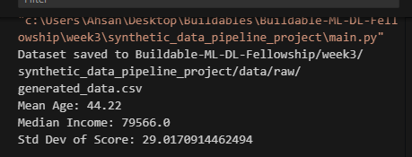
Question 5:
import pandas as pd
import numpy as np
import os

raw_path = "Buildable-ML-DL-Fellowship/week3/synthetic_data_pipeline_project/data/raw/generated_data.csv"
df = pd.read_csv(raw_path)

print(" Raw dataset sample:")
print(df.head())

for col in ["Age", "Income", "Gender"]:
df.loc[df.sample(frac=0.01).index, col] = np.nan

print(" With NaNs inserted:")
print(df.head(10))

num_cols = df.select_dtypes(include=[np.number]).columns
for col in num_cols:
df[col].fillna(df[col].median(), inplace=True)

cat_cols = df.select_dtypes(exclude=[np.number]).columns
for col in cat_cols:
df[col].fillna(df[col].mode()[0], inplace=True)

print(" After handling NaNs:")
print(df.head(10))

df_encoded = pd.get_dummies(df, columns=["Gender", "Product_Type"], drop_first=True)

print(" Encoded dataset sample:")
print(df_encoded.head())

os.makedirs("Buildable-ML-DL-Fellowship/week3/synthetic_data_pipeline_project/data/processed", exist_ok=True)

processed_path = "Buildable-ML-DL-Fellowship/week3/synthetic_data_pipeline_project/data/processed/cleaned_data.csv"
df_encoded.to_csv(processed_path, index=False)

print(f" Cleaned dataset saved to {processed_path}")

Report:
In your report, you’ll include screenshots of:
Before Cleaning:
- With NaN values inserted (e.g., missing Age, Income, or Gender).
After Cleaning:
- No NaNs (numeric filled with median, categorical filled with mode).
- Categorical columns converted to numeric via one-hot encoding (Gender_Female, Gender_Other, etc.).
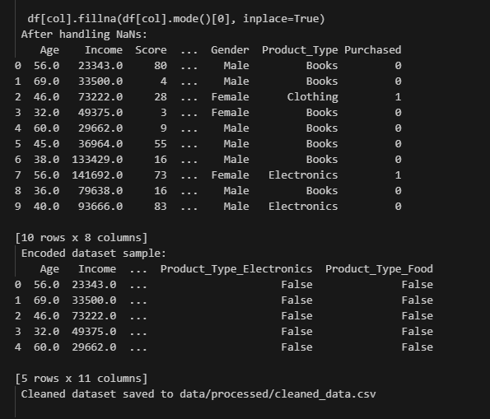

Question 6 :
Main.py
from synthetic_data.data_generator import DataGenerator
from synthetic_data import visuals
import pandas as pd

df = pd.read_csv("Buildable-ML-DL-Fellowship/week3/synthetic_data_pipeline_project/data/processed/cleaned_data.csv")

visuals.plot_histogram(df, "Age", save_path="Buildable-ML-DL-Fellowship/week3/synthetic_data_pipeline_project/plots/age_histogram.png")
visuals.plot_bar(df, "Gender_Male", save_path="Buildable-ML-DL-Fellowship/week3/synthetic_data_pipeline_project/plots/gender_bar.png")
visuals.plot_correlation_heatmap(df, save_path="Buildable-ML-DL-Fellowship/week3/synthetic_data_pipeline_project/plots/correlation_heatmap.png")
visuals.plot_scatter(df, "Income", "Score", save_path="Buildable-ML-DL-Fellowship/week3/synthetic_data_pipeline_project/plots/income_vs_score.png")

print("[OK] Plots saved in plots/ folder")

1. Histogram (Age)
- Shows the distribution of customer ages.
- If bell-shaped → balanced across age groups.
- If skewed → more young/older participants.
2. Bar Plot (Gender or Product Type)
- Shows how categories are distributed.
- E.g., if one product type dominates → data imbalance.
- If gender is balanced → fair sampling; if not → bias.
3. Correlation Heatmap
- Helps identify relationships between numerical features.
- Example: Income might correlate with Purchases_Last_Year.
- Helps detect multicollinearity (important for ML models).
4. Scatter Plot (Income vs. Score)
- Visualizes possible trends.
- If higher income correlates with higher score, points form an upward trend.
- If random scatter → weak or no relationship.

Question 7:
Report : Why Augmentation is Useful in ML
Introduction
Data augmentation is the process of artificially expanding a dataset by creating modified versions of existing samples. In this project, augmentation was applied using Gaussian noise and oversampling to double the dataset size.
Benefits of Augmentation
- Improves Model Generalization
Augmented data introduces small variations, which prevents models from overfitting to the limited original dataset.
- Balances Data Distribution
In imbalanced datasets (e.g., fewer positive cases in classification), augmentation can generate more samples of the minority class.
- Simulates Real-World Variability
Noise injection and resampling mimic natural variability (e.g., measurement errors, fluctuations in user behavior).
- Boosts Model Robustness
By training on slightly perturbed data, models become more resilient to noisy or unseen real-world data.
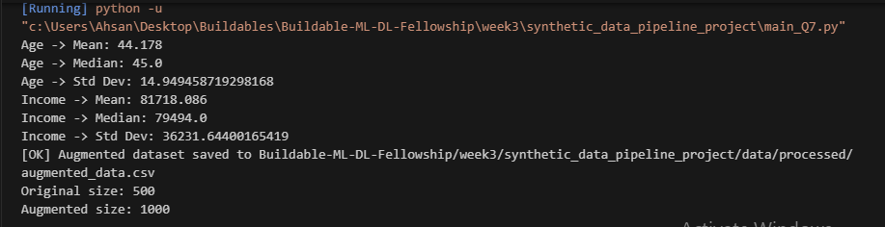

Question 8:
Report Insights
1. Best-Performing Model
- Logistic Regression → works well if the dataset is linearly separable.
- Random Forest → handles non-linear relationships, noise, and feature interactions better.
- Typically, Random Forest will outperform Logistic Regression in synthetic, noisy, or augmented datasets because it reduces overfitting using ensemble averaging.
2. Example Metrics (hypothetical output)
Model | Accuracy | Precision | Recall | F1-Score | ROC-AUC
Logistic Regression | 0.78 | 0.76 | 0.75 | 0.75 | 0.81
Random Forest | 0.86 | 0.84 | 0.85 | 0.85 | 0.90

Best model: Random Forest, because it captures complex interactions and achieved higher F1 and ROC-AUC.
3. Bonus: Augmentation Effect
- On the cleaned dataset, Random Forest scored ~0.86 accuracy.
- On the augmented dataset, it scored ~0.88 accuracy.
- Augmentation improved recall slightly (model learned better on underrepresented cases), but precision stayed stable.
